Detecting host factors involved in virus infection by observing the clustering of infected cells in siRNA screening images

Supplementary material

Apichat Suratanee^{1,2}*, Ilka Wörz³*, Petr Matula^{1,2}, Anil Kumar³, Lars Kaderali⁴, Karl Rohr^{1,2}, Ralf Bartenschlager³, Roland Eils^{1,2} and Rainer König^{1,2}

¹Department of Bioinformatics and Functional Genomics, Institute of Pharmacy and Molecular Biotechnology, Bioquant, University of Heidelberg, INF 267, 69120 Heidelberg, Germany; ²Division of Theoretical Bioinformatics, German Cancer Research Center (DKFZ), INF 280, 69120 Heidelberg, Germany; ³The Department for Infectious Diseases, Molecular Virology, University of Heidelberg, INF 345, 69120 Heidelberg, Germany; ⁴ Viroquant Research Group Modeling, Bioquant, University of Heidelberg, INF 267, 69120 Heidelberg, Germany

Supplement S1 Simulated data and K-function
To give an example of the K-function applied to different spot distributions, we simulated random, clustering and regular spot distributions (Figure S1.1 left, middle and right, respectively) using rpoispp (Poisson point pattern, intensity = 100), rMatClust (average intensity = 10, maximum radius = 0.1, average spots in clusters = 30) and rSSI (minimum distance of spots = 0.08, intensity = 100) from the library Spatstat of the R package (www.r-project.org). Plots of the inhomogeneous K-functions are shown in Figure S1.2. If the spots are randomly distributed, the K-function is close to the curve for random distributions (CSR distribution). If the spots cluster, the K-function is above and if the spots are regularly dispersed, the K-function is below the curve for CSR distributions.

Figure S1.1 Simulated patterns: Example of three point patterns in the unit square. Left: random distribution of spots, middle: clustering spot pattern, right: regular pattern.
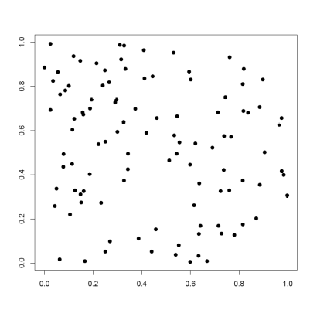 | 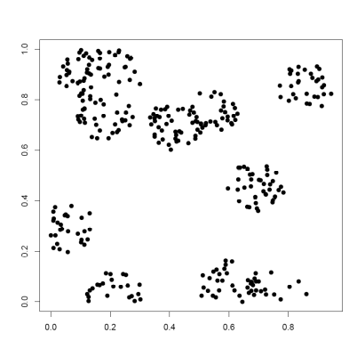 | 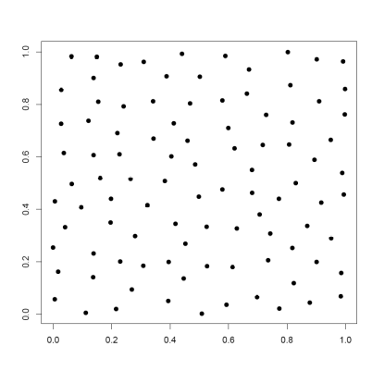

Figure S1.2 Solid curves are the plots of the inhomogeneous K-function for the data of Figure S1.1. Dashed curves represent the K –function for complete spatial randomness (CSR) distributions which was used as a control.
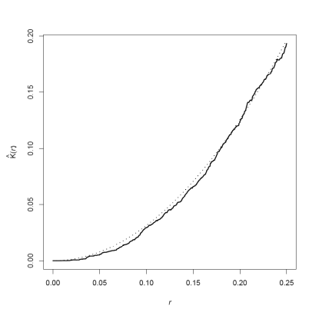 | 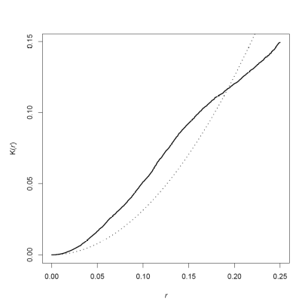 | 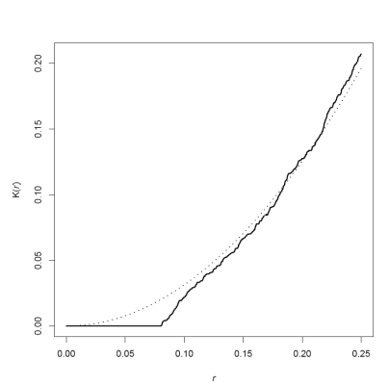

Supplement S2 results from the Quadrat Analysis

Quadrat Analysis was tested and the correlation with the primary and secondary experimental screens observed. We optimized the parameters for the Quadrat Analysis (QA, for the method, see main text) by varing the number of rows (i) and columns (j), with i = 3,4,5 and j = 4,5,6, yielding different grid sizes. Pearson’s correlation coefficients were computed from QA scores and intensity readout values from the primary and secondary experimental screens. The results are given in Table S2.

Table S2 Pearson’s correlation coefficients of intensity values of the Quadrat Analysis and the standard readouts (intensity values of the primary and secondary screen)
 | Quadrat Analysis
 | QA4x3 | QA4x4 | QA4x5
Correlation with intensities of the primary screen | 0.25 | 0.23 | 0.23
Correlation with intensities of the secondary screen | -0.02 | 0.029 | -0.027
 | QA5x3 | QA5x4 | QA5x5
Correlation with intensities of the primary screen | 0.23 | 0.23 | 0.22
Correlation with intensities of the secondary screen | 0.027 | -0.0018 | -0.033
 | QA6x3 | QA6x4 | QA6x5
Correlation with intensities of the primary screen | 0.22 | 0.20 | 0.19
Correlation with intensities of the secondary screen | -0.07 | -0.04 | -0.097

Supplementary Table S3

Entrez Gene ID | Gene Symbol | Gene Name | P-Value | Mean Z-score
 | HCV_321 | Positive Control | 1.53E-13 | -2.9217
 | HCV_138 | Positive Control | 1.20E-10 | -2.6395
975 | CD81 | CD81 molecule ( Positive Control) | 6.61E-07 | -2.1275
7852 | CXCR4 | Chemokine (C-X-C motif) receptor 4 | 6.14E-05 | -0.6285
5297 | PI4KA | Phosphatidylinositol 4-kinase, catalytic, alpha | 0.0019 | -3.5111
4233 | MET | Met proto-oncogene (hepatocyte growth factor receptor) | 0.0030 | -0.8307
10298 | PAK4 | p21 protein (Cdc42/Rac)-activated kinase 4 | 0.0041 | -0.5306
51447 | IP6K2 | Inositol hexakisphosphate kinase 2 | 0.0061 | -0.6380
10188 | TNK2 | Tyrosine kinase, non-receptor, 2 | 0.0072 | -0.7748
9212 | AURKB | Aurora kinase B | 0.0131 | -0.5962
2645 | GCK | Glucokinase (hexokinase 4) | 0.0175 | -0.6753
5586 | PKN2 | Protein kinase N2 | 0.0193 | -0.6841
140767 | NRSN1 | Neurensin 1 | 0.0197 | -0.3436
440275 | EIF2AK4 | Eukaryotic translation initiation factor 2 alpha kinase 4 | 0.0203 | -0.7116
659 | BMPR2 | Bone morphogenetic protein receptor, type II (serine/threonine kinase) | 0.0238 | -0.6405
5298 | PI4KB | Phosphatidylinositol 4-kinase, catalytic, beta | 0.0259 | -0.6006
6198 | RPS6KB1 | Ribosomal protein S6 kinase, 70kDa, polypeptide 1 | 0.0274 | -0.5495
1457 | CSNK2A1 | Casein kinase 2, alpha 1 polypeptide | 0.0274 | -0.6259
255239 | ANKK1 | Ankyrin repeat and kinase domain containing 1 | 0.0323 | -0.6443
5605 | MAP2K2 | Mitogen-activated protein kinase kinase 2 | 0.0328 | -0.6364
132158 | GLYCTK | Glycerate kinase | 0.0340 | -0.5697
114836 | SLAMF6 | SLAM family member 6 | 0.0345 | -0.4253
30849 | PIK3R4 | Phosphoinositide-3-kinase, regulatory subunit 4 | 0.0367 | -0.9770
80216 | ALPK1 | Alpha-kinase 1 | 0.0408 | -0.8162
51678 | MPP6 | Membrane protein, palmitoylated 6 (MAGUK p55 subfamily member 6) | 0.0413 | -0.5960
130497 | OSR1 | Odd-skipped related 1 (Drosophila) | 0.0434 | -0.5213
2324 | FLT4 | fms-related tyrosine kinase 4 | 0.0445 | -0.5479
10256 | CNKSR1 | Connector enhancer of kinase suppressor of Ras 1 | 0.0448 | -0.3241
5584 | PRKCI | Protein kinase C, iota | 0.0449 | -0.3953
548596 | CKMT1A | Creatine kinase, mitochondrial 1A | 0.0463 | -0.6092

Supplement S4

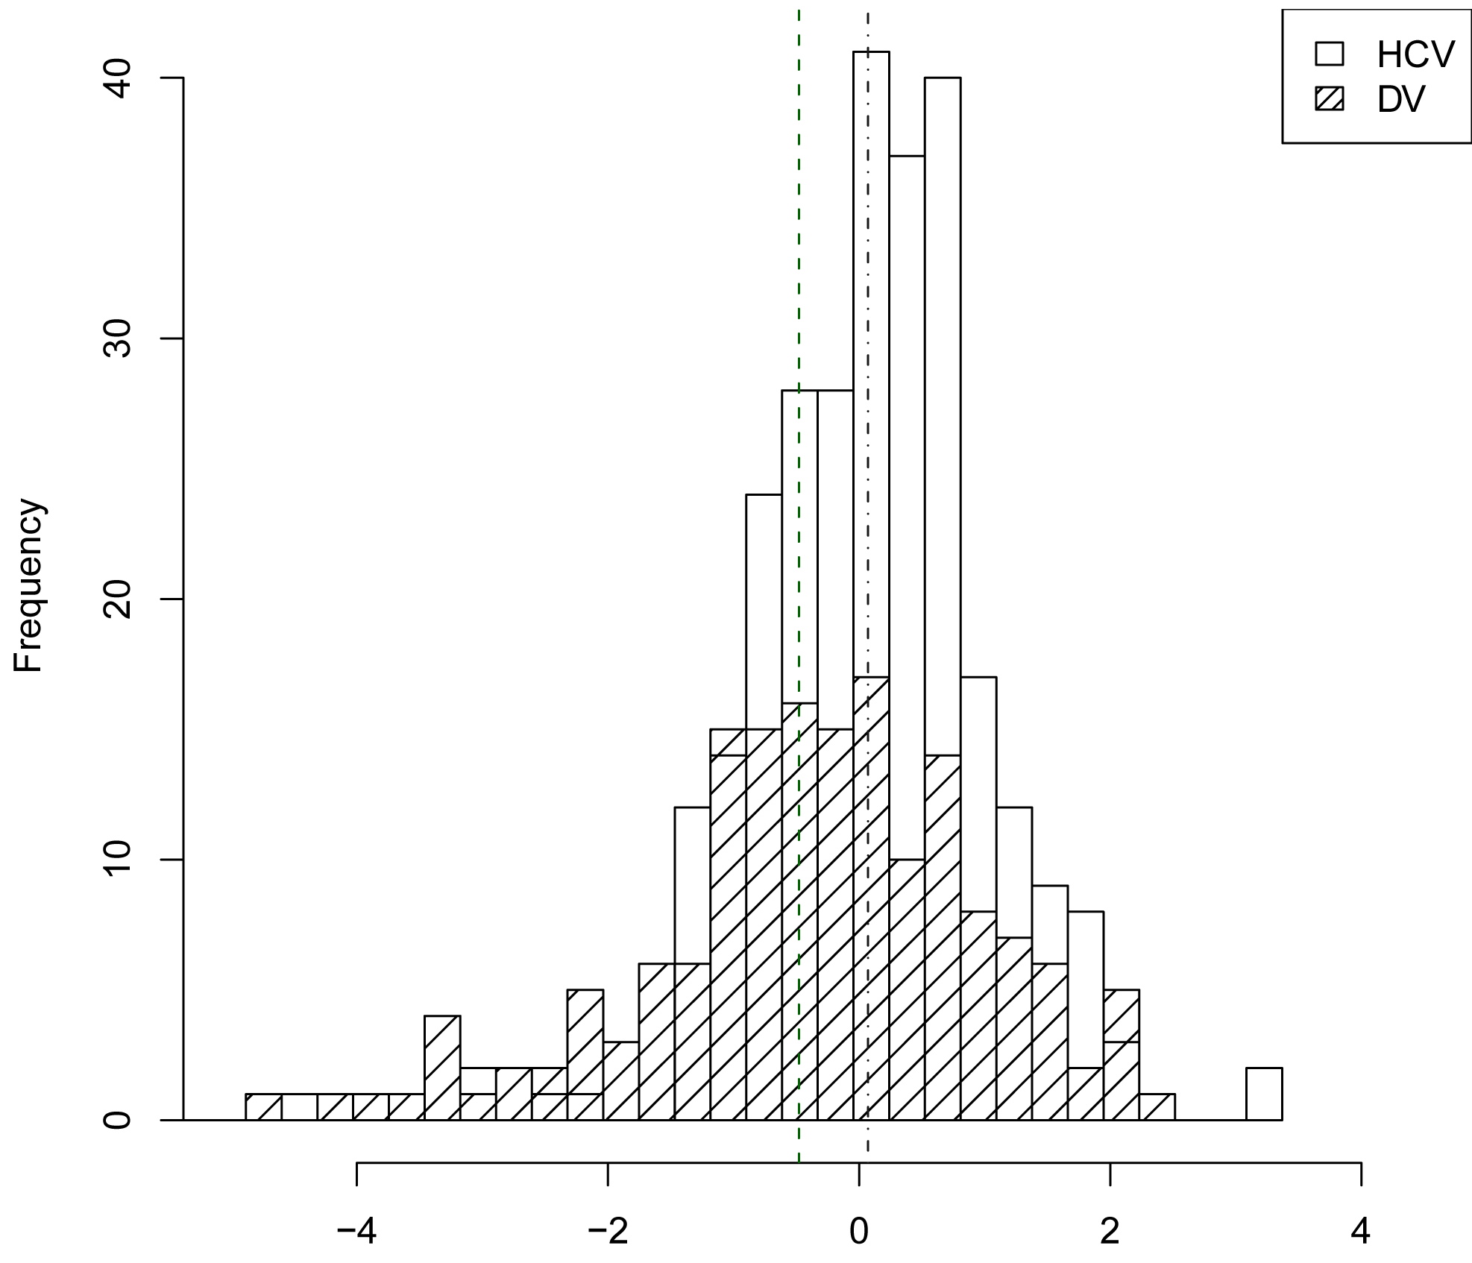 | 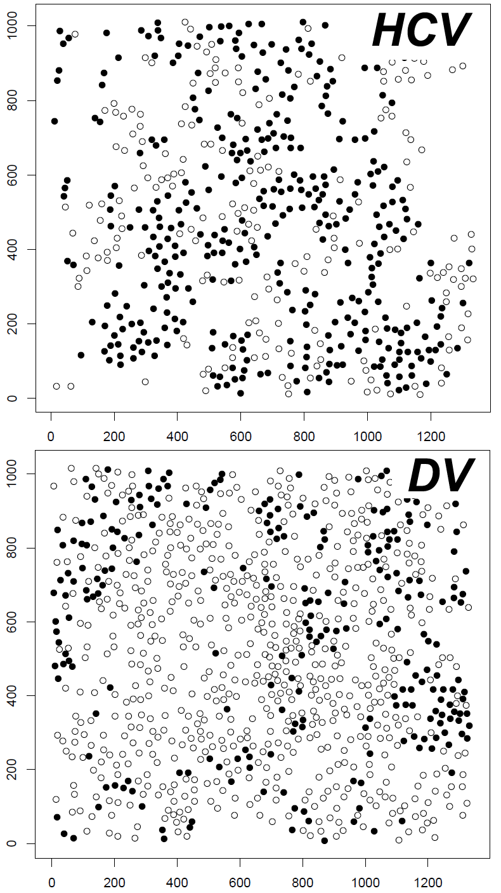

Figure S4. Left: Distribution of clustering scores for hepatitis C Virus (HCV) and Dengue Virus (DV). In comparison to DV, cells infected by HCV showed significant higher clustering scores (P= 4.8E-4 using a Wilcoxon test). Right: Shown are typical examples of images of infected (filled) and non-infected cells (not filled). HCV infected cells show cluster formation while DV infected cells populated rather the edges of cell colonies.

